
ASSIGNMENT 9: ADVANCED SQL QUERIES USING JOINS AND SUBQUERIES
DATABASE MANAGEMENT SYSTEM
ALLIANCE UNIVERSITY
Department of Computer Applications
SUBMITTED BY: RUPESH RL
REGISTER NO: 2511021240035
COURSE: BCA
YEAR: 2ND YEAR
PROJECT NAME: Courier and Parcel Delivery Management System

1. Aim
To write advanced SQL queries on the courier database using joins and subqueries, and to prepare useful reports for the company from more than one table. For each report I give the query, the output and a short explanation.

2. Joins and Subqueries Used
Type | Meaning | Where I used it
INNER JOIN | Gives only the rows that have a matching row in both tables. | Reports 1, 2, 4, 6, 7, 8, 9
LEFT JOIN | Gives all rows of the left table, even when there is no match on the right. The missing side shows NULL or 0. | Reports 3, 5
Self join | A table joined with itself, using two different names (aliases). | Report 10
Subquery in WHERE | A query inside another query, used to compare with a calculated value or a list. | Reports 11, 12, 13, 16, 17
Correlated subquery | A subquery that uses a value from the outer query, so it runs again for each outer row. | Reports 14, 18
Subquery in FROM | A subquery used like a temporary table. | Report 15

Branch is joined twice in some queries (once for the booking branch and once for the destination branch), so I give them different aliases bk and ds.

3. Reports Using Joins

Report 1: Parcel register (five tables)
Parcel stores only IDs. To get a readable report, the sender, the receiver and the two branches are fetched from their own tables. Only the first 12 parcels are shown to save space.
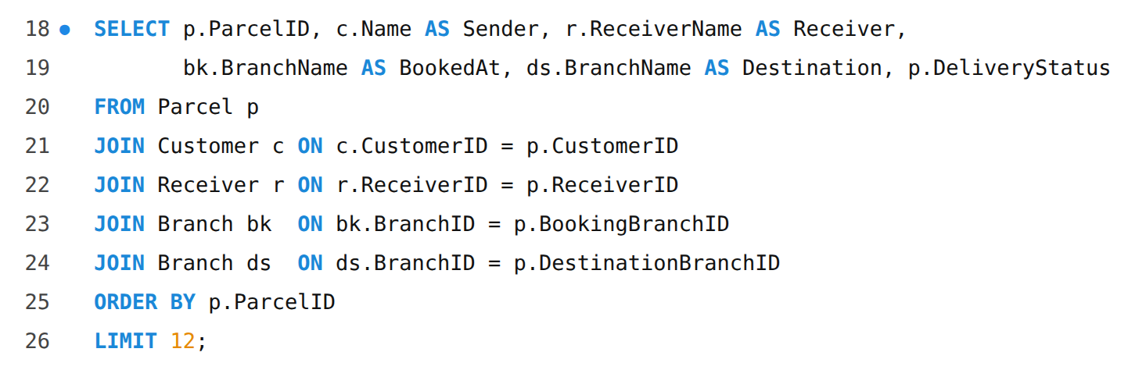
Output:
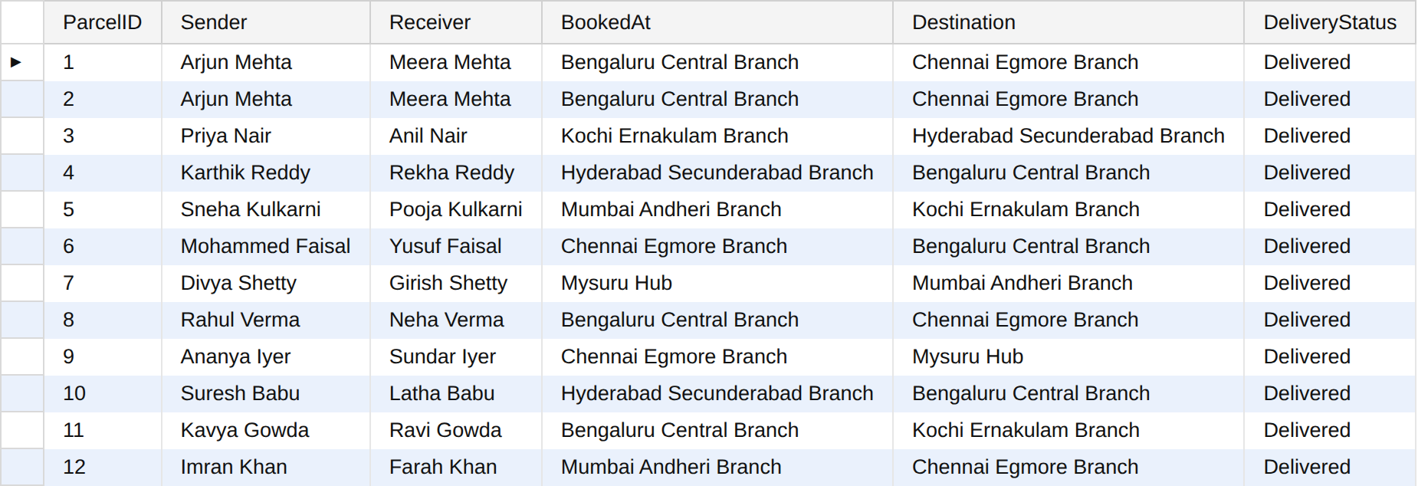

Report 2: Delivery report with employee, vehicle and delay (four tables)
This report joins Delivery_Assignment with Employee and Vehicle. DATEDIFF gives the difference in days between the actual and the expected date, so a negative value means the parcel came before the expected date. CASE gives the label Late or On time. Only completed deliveries are included.
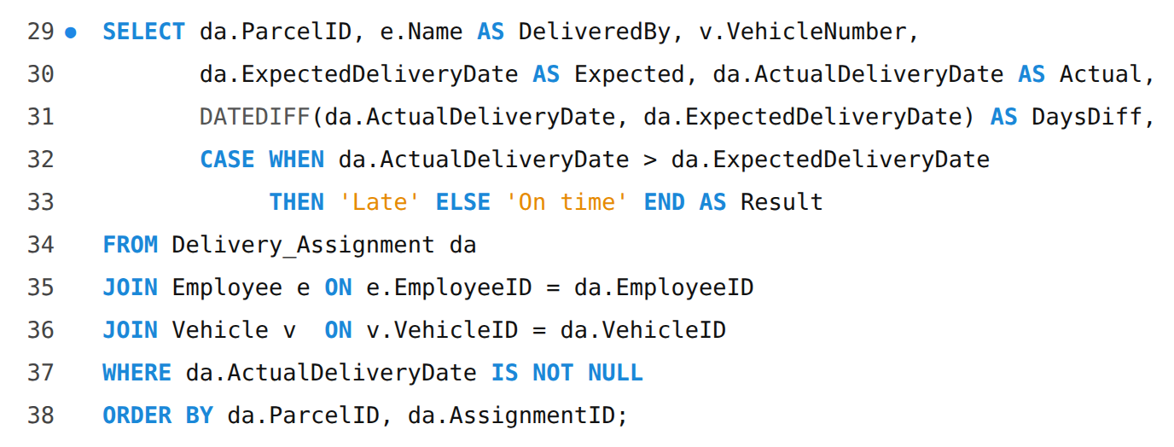
Output:
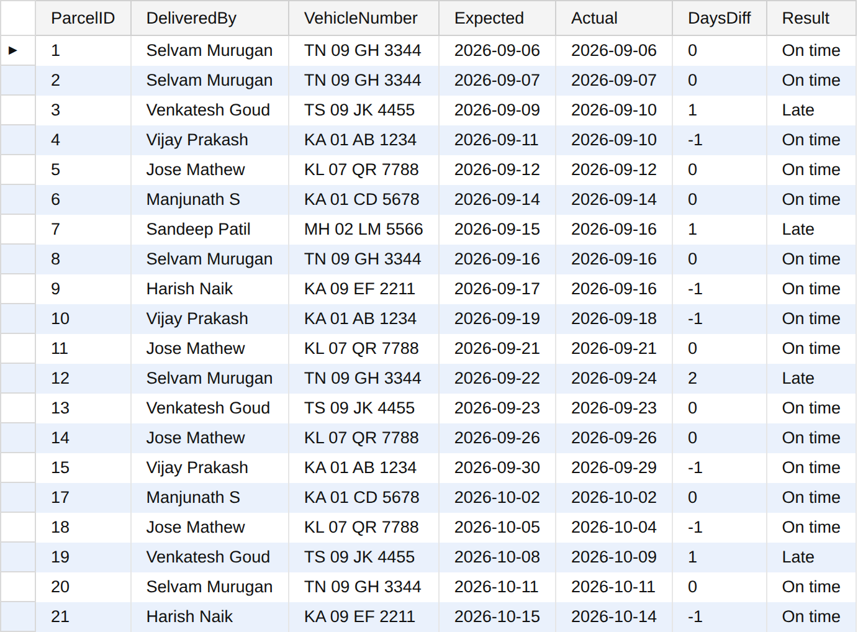
There are 20 completed deliveries. 4 of them were late.

Report 3: Parcels not yet assigned to anyone (LEFT JOIN)
LEFT JOIN keeps every parcel even when it has no assignment. For those parcels the columns of Delivery_Assignment are NULL, so WHERE da.AssignmentID IS NULL finds exactly the parcels with no assignment. These are the parcels that have not reached the destination branch yet.
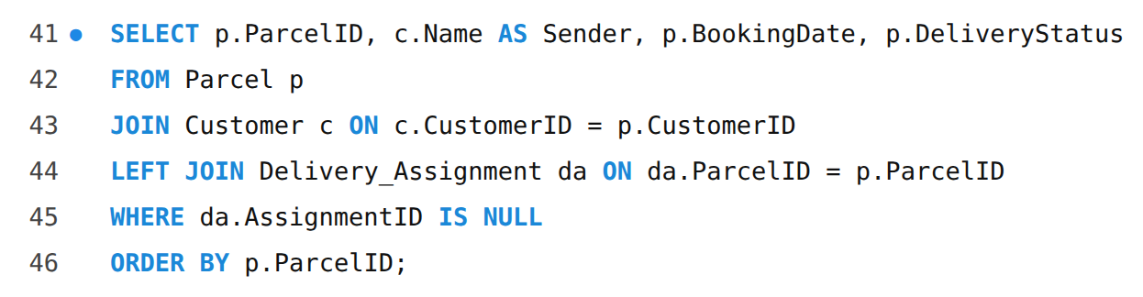
Output:
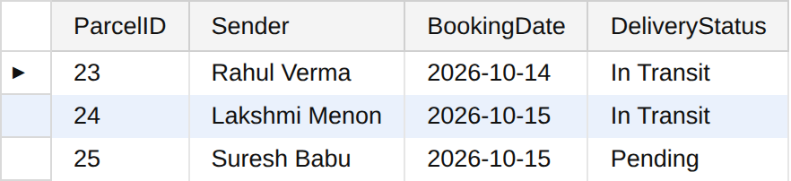

Report 4: Employee performance
Joins three tables, then groups by employee. For every employee it counts the completed deliveries and finds the average number of days between the assigned date and the delivery date.
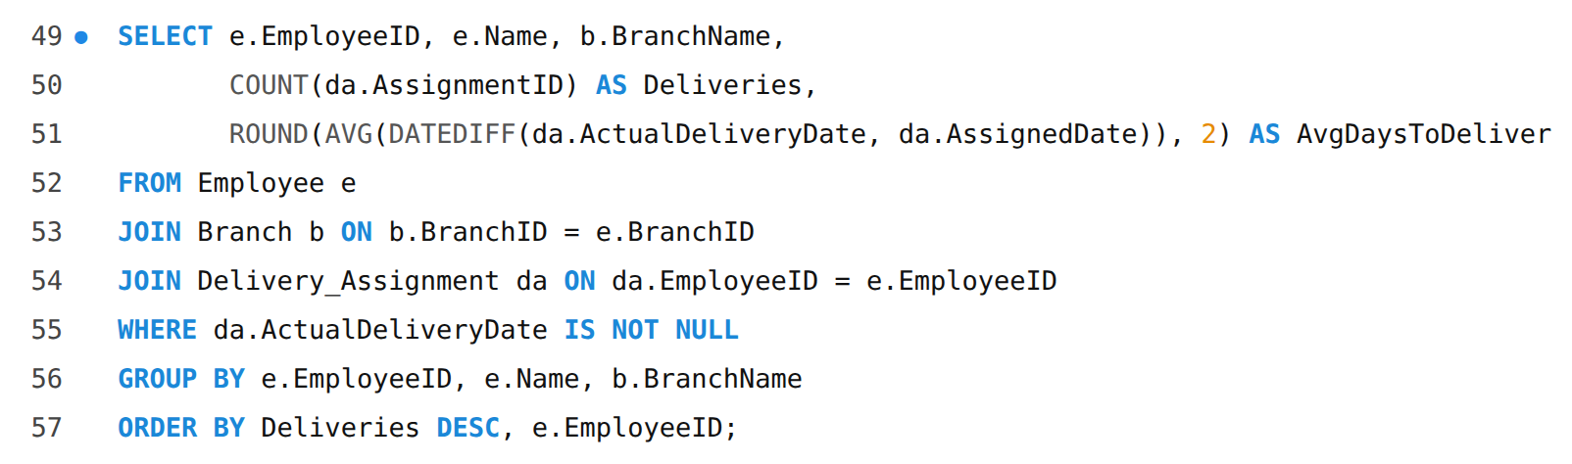
Output:
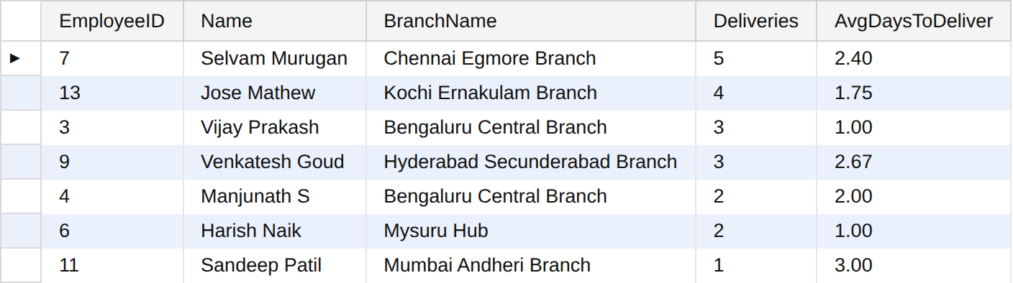

Report 5: All employees with their number of assignments (LEFT JOIN)
With a normal join, employees who never delivered anything (managers and clerks) would disappear from the result. LEFT JOIN keeps them with a count of 0. COUNT(da.AssignmentID) is used instead of COUNT(*) because COUNT(*) would count the empty row as 1.
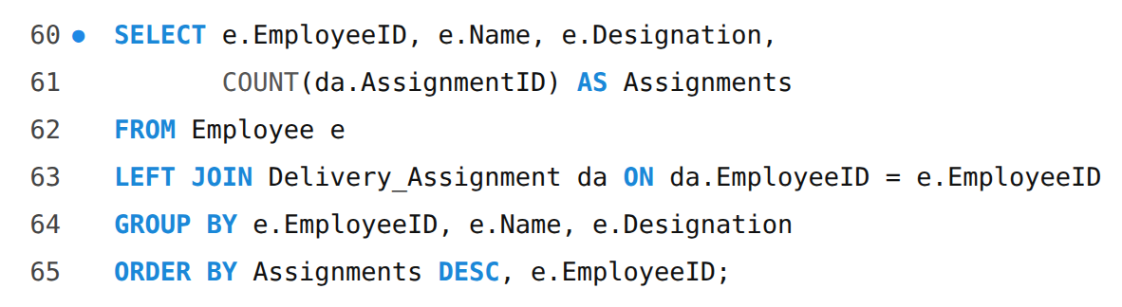
Output:
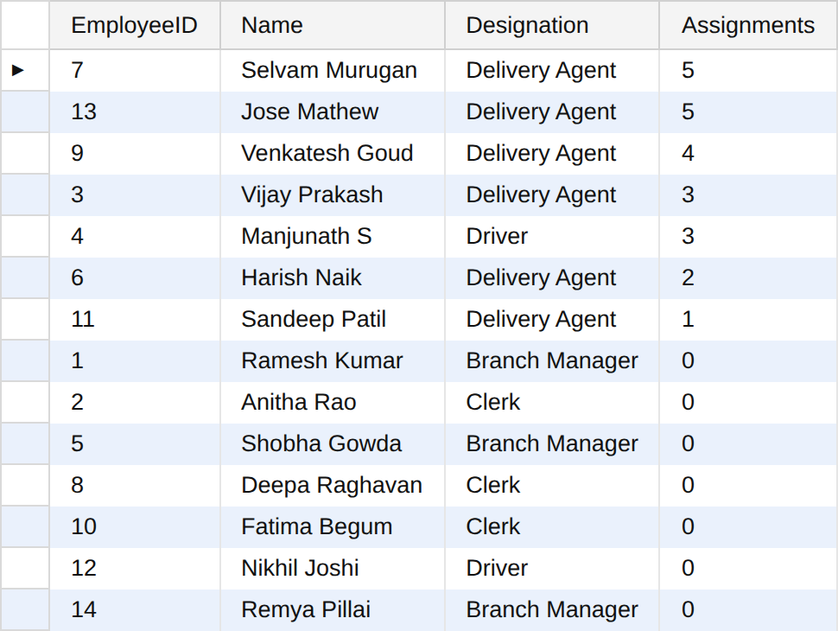

Report 6: Vehicle usage
This report helps the company to see which vehicles are used more and which are not used at all. A vehicle with 0 has no assignment yet.
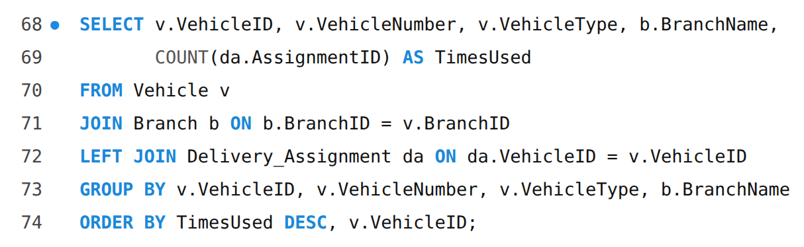
Output:
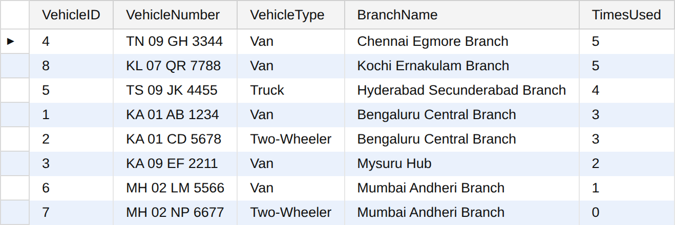
The vehicle MH 02 NP 6677 (Mumbai Andheri Branch) has not been used for any delivery.

Report 7: Branch-wise revenue
Revenue is counted for the branch where the parcel was booked, and only paid payments are included.
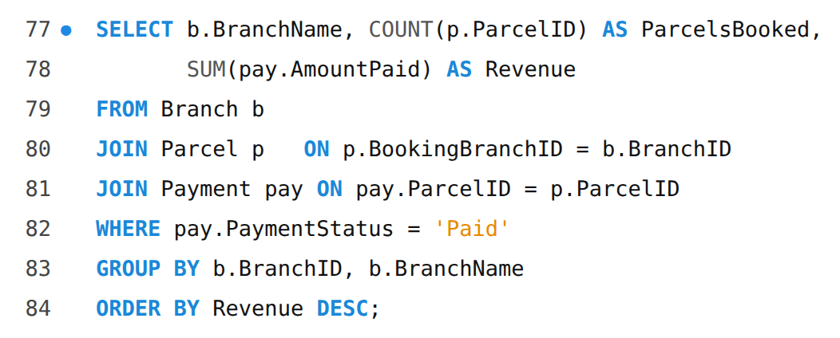
Output:
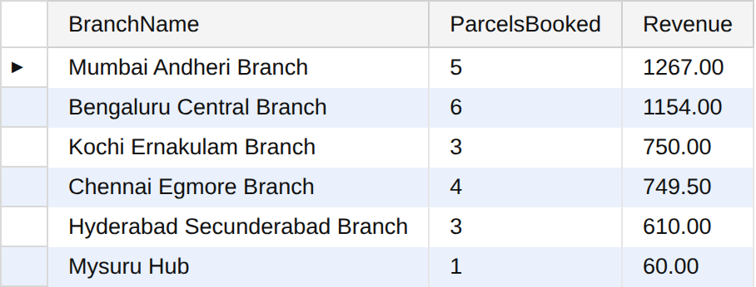

Report 8: Complete tracking history of parcel 15
This is what a customer would see when tracking a parcel. Parcel 15 is the one that needed a second attempt, so the history shows Delivery Failed first and then Out for Delivery and Delivered on a later day.
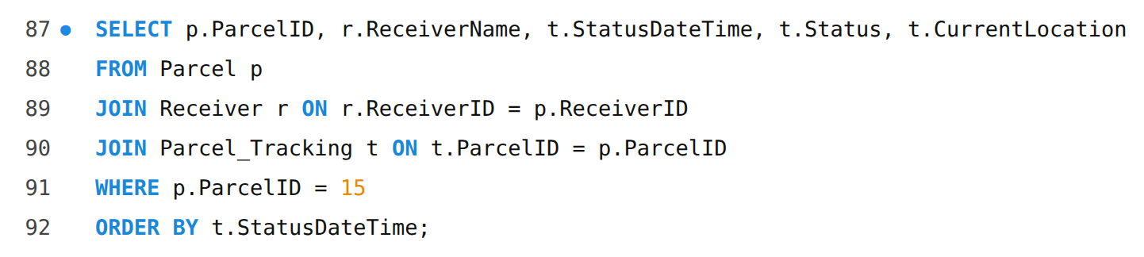
Output:
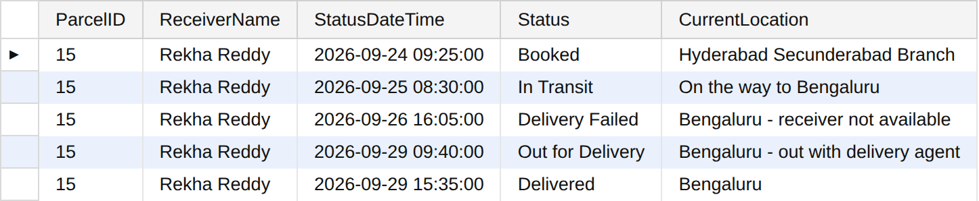

Report 9: Complaint report
Complaint has no CustomerID in the final design, so the customer is found through the Parcel table. This is why Complaint is joined to Parcel first and then Parcel to Customer.
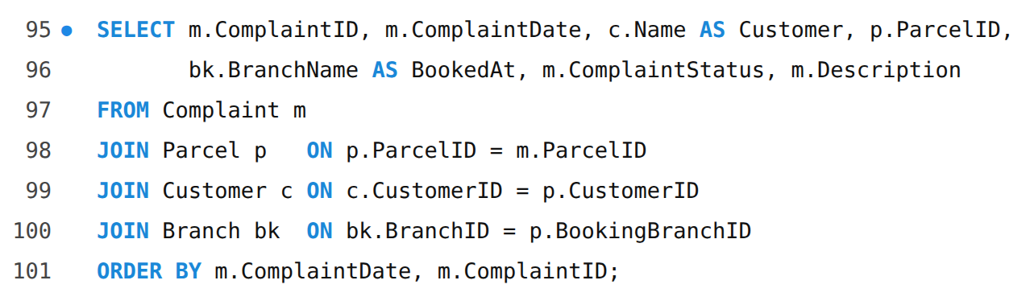
Output:
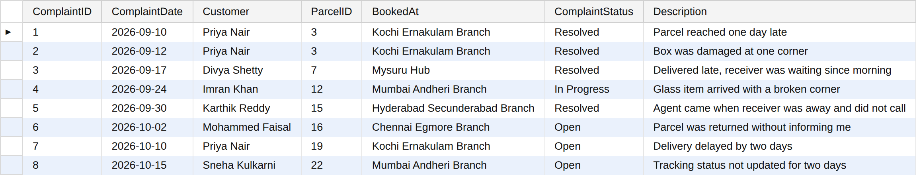

Report 10: Colleagues of Ramesh Kumar (self join)
The Employee table is used twice: e1 is Ramesh Kumar and e2 is every other employee of the same branch. The condition e1.EmployeeID <> e2.EmployeeID removes Ramesh himself from the list.
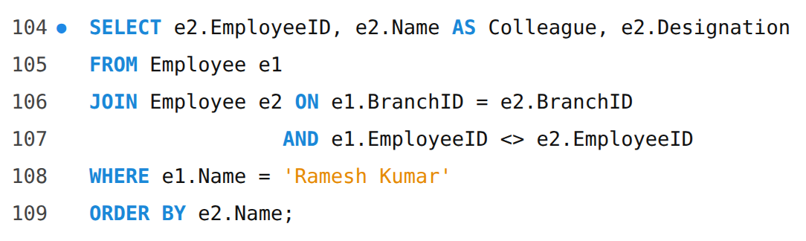
Output:
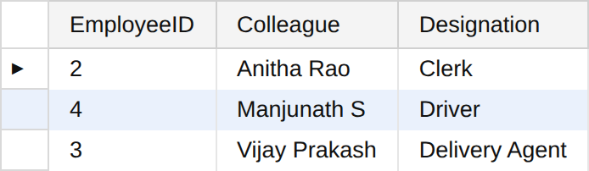

4. Reports Using Subqueries

Report 11: Parcels heavier than the average weight
The inner query gives one value, the average weight of all parcels. The outer query then lists the parcels above it. If the data changes, the average is calculated again automatically.
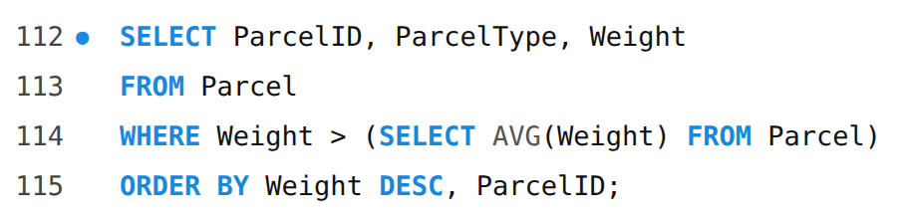
Output:
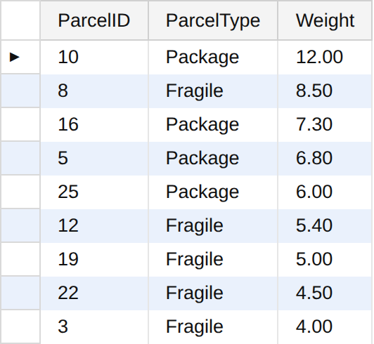

Report 12: Customers who have raised a complaint
This has two levels of subquery. The innermost gives the parcels that have complaints, the next gives the customers of those parcels, and the outer query shows those customers.
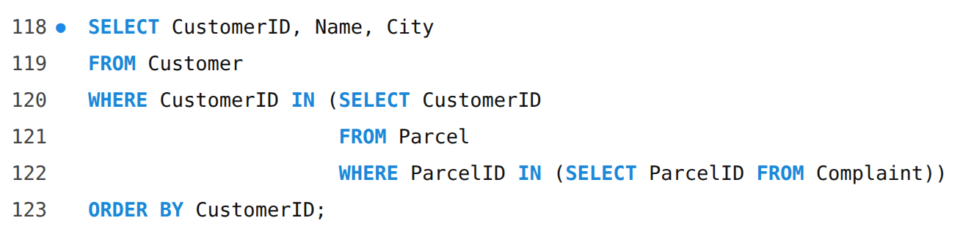
Output:
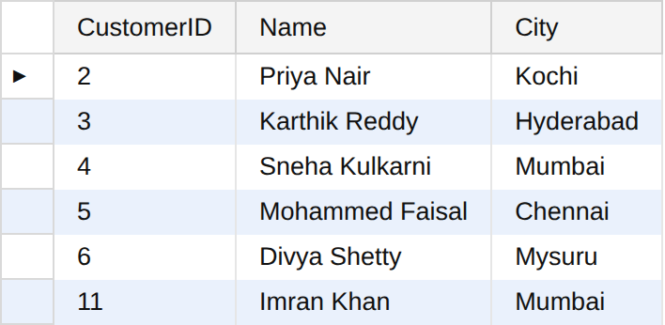

Report 13: Customers who never raised a complaint
NOT EXISTS keeps the customers for whom the subquery finds no row. These are the customers who are satisfied, which is useful for the company to know.
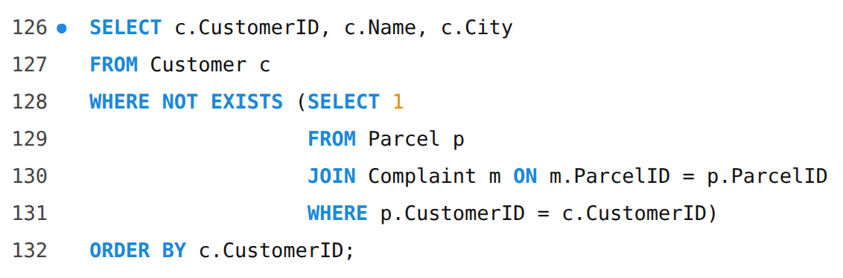
Output:
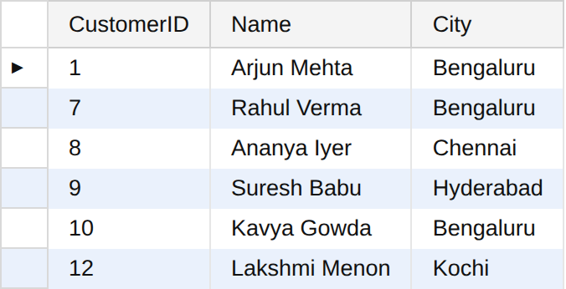

Report 14: Payments above the average of the same parcel type (correlated subquery)
The inner query uses p.ParcelType from the outer query, so the average is worked out again for each parcel, using only the payments of its own type. A document is compared with documents, and a fragile parcel with fragile parcels.
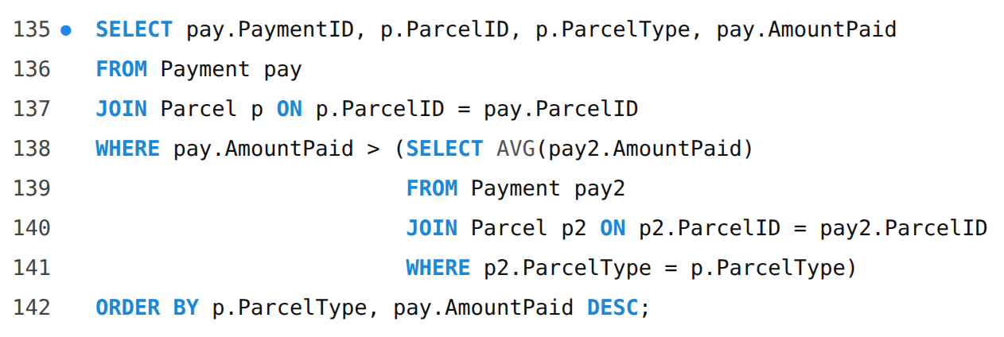
Output:
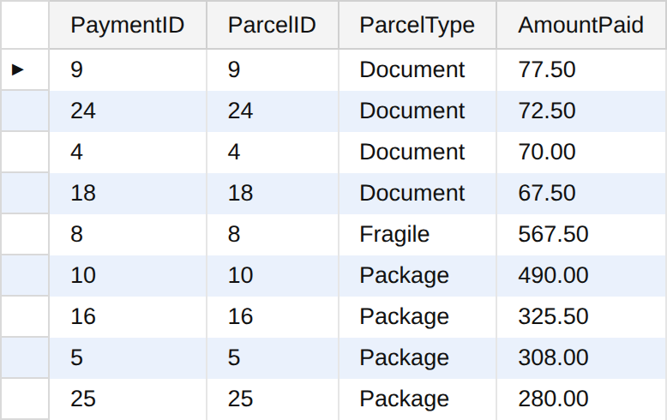

Report 15: Branches that booked more than the average number of parcels (subquery in FROM)
The subquery in FROM makes a temporary table t with the parcels booked by each branch. The second subquery finds the average number per branch (25 parcels over 6 branches is about 4.17). Branches above this average are shown.
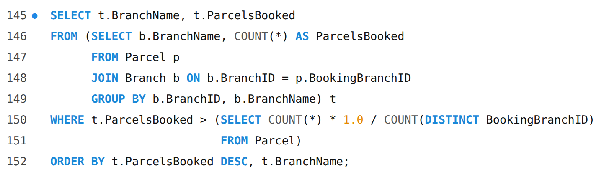
Output:
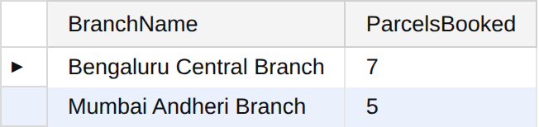

Report 16: Parcel(s) with the highest payment
The subquery finds the maximum amount, and the outer query shows the parcel that was charged that amount.
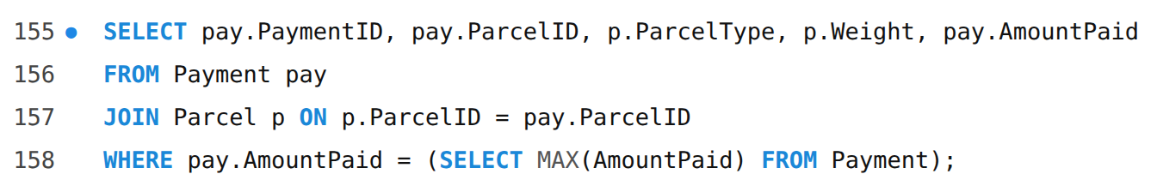
Output:
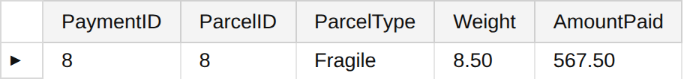

Report 17: Late deliveries with receiver details
The subquery picks the parcels whose actual delivery date is after the expected date. The outer query adds the receiver details. These are the parcels that the company should look at to improve service. Parcels 3, 7, 12 and 19 also have complaints in the sample data.
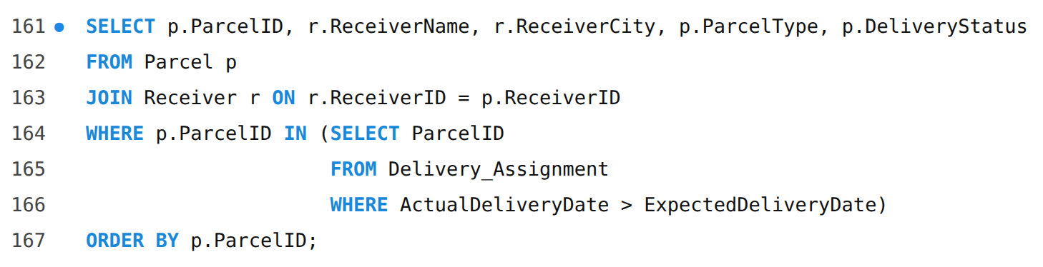
Output:
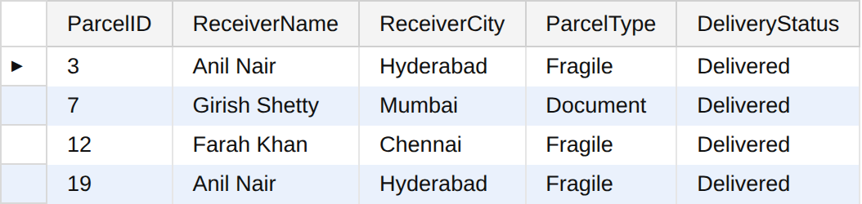

Report 18: Customer summary (correlated subqueries in SELECT)
For each customer the three subqueries find the number of parcels, the total amount paid and the number of complaints. I used subqueries here instead of joining all the tables together, because joining Parcel, Payment and Complaint in one query would repeat rows and make the counts wrong.
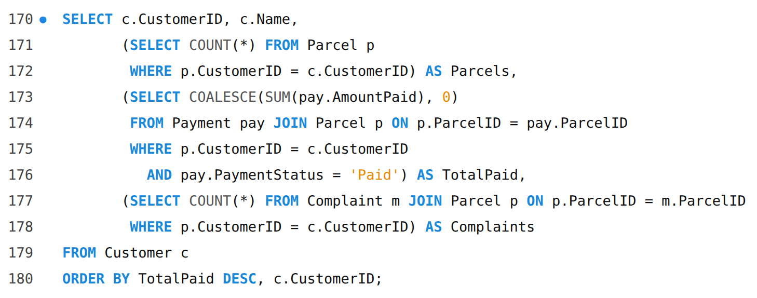
Output:
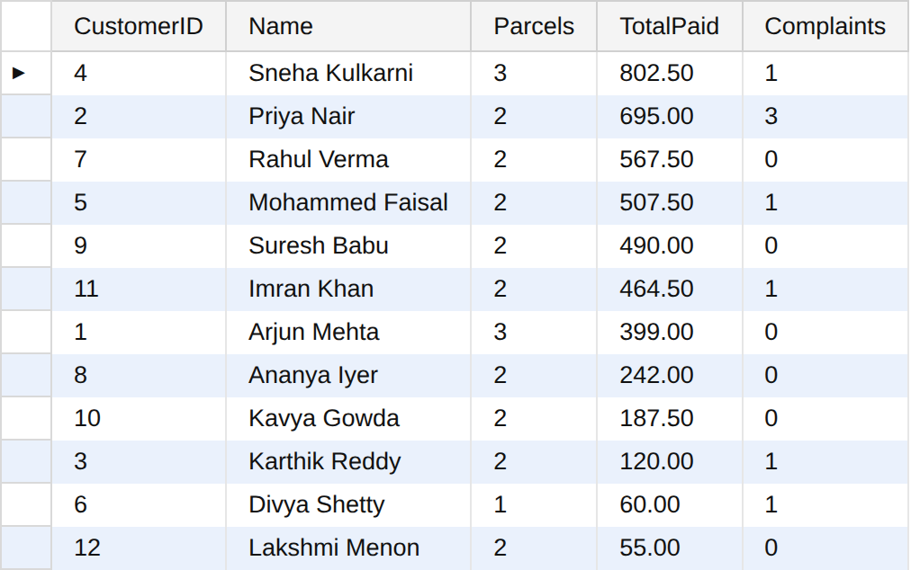

5. Summary Statistics Report

Report 19: Delivery performance of the company
A single row of summary figures for the management. CASE inside SUM is a way of counting rows that satisfy a condition.
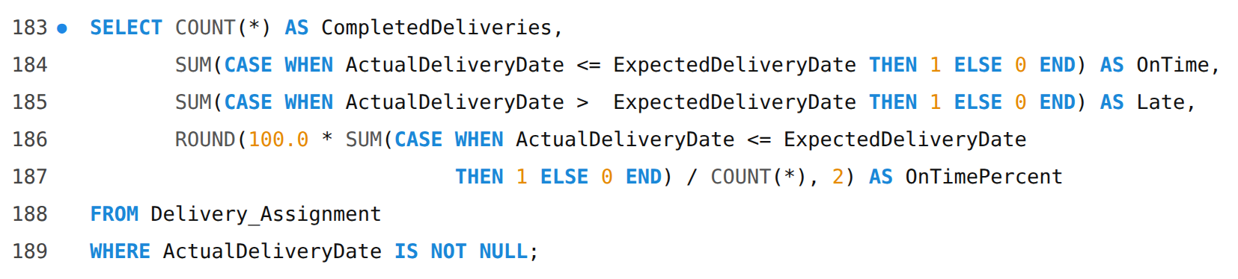
Output:
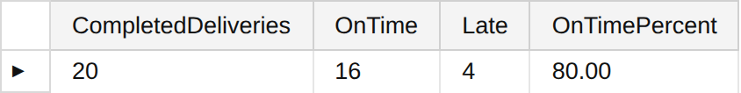

Report 20: Money position by payment status
Shows how much money has been received and how much is pending or failed.
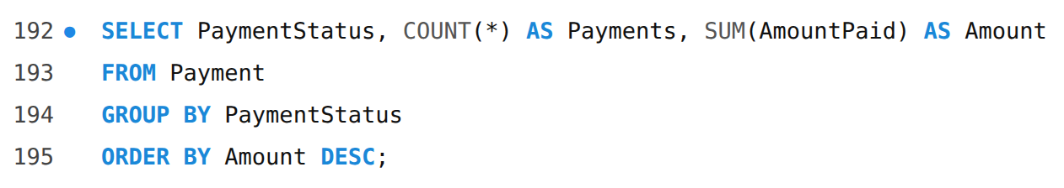
Output:
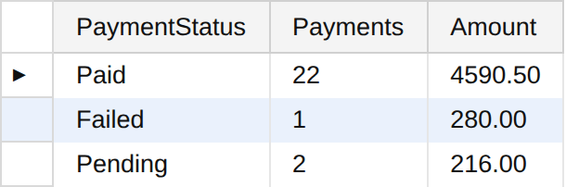

6. Result
Twenty reports were prepared using joins and subqueries on the courier database, and the output of each one was checked.

7. Conclusion
Joins helped me to bring the data of many tables into readable reports like the parcel register, delivery report, employee performance, vehicle usage, branch revenue, tracking history and complaint report. LEFT JOIN helped to find parcels with no assignment and employees and vehicles with no work. Subqueries helped to compare values with the average or the maximum, to find customers with and without complaints, and to make a customer summary. This shows that data stored in separate tables without repetition can still answer the real questions of the courier company.

